HOLY TRINITY TAUNTON

O
U
T
L
O
O
K
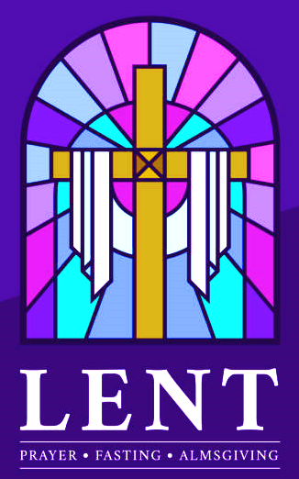

March 2025

Holy Trinity Service Times

Services are as follows:

Sunday
8.00am, 10.00am* & 4.00pm*

Tuesday*, Wednesday* & Thursday* 10.00am
Friday* 12.30pm

Saturday
10.00am* and 6.00pm

Service times may occasionally vary – please see weekly notice sheet for details.

All services are streamed except Saturday 6pm & Sunday 8am.
* Streamed on YouTube * Streamed on Facebook

To access streamed services:


www.youtube.com/@holytrinitytaunton

@ Holy Trinity Taunton

Holy Trinity Taunton

Fr Julian can be emailed directly: frjulianssc@gmail.com


Please use this QR code if you would like to make a donation to Holy Trinity

HOLY TRINITY CHURCH HALL

is available for hire
for training, parties, regular events

Disabled Access
On-site parking available

Competitive rates

To book please contact the Church Administrator
Tel: 01823 354800
Email: holytrinity01@outlook.com



Nick‘s
Silver Birch Garden Services
Est. 1995

For gardens large and small

Lawn mowing and strimming. Scarifying moss and weeds.

Hedge-cutting and trimming. Rotavating. Tree pruning.

Pressure washing. Felt roofs replaced on garden sheds.

Stone walling repairs & renovations, steps and pavings etc.

References available

For a friendly, professional service call Nick
Tel: 07535 498529

QUEEN STREET GARAGE

Car repairs, Servicing and MOT

We are a small family run business.
Our staff have over 30 years experience.
All our technicians are fully qualified and
attend ongoing training.

SERVICES AVAILABLE

MOTS
Servicing
Repairs
Diagnostic Checks
Air Con Services and Repairs
Brakes, Exhausts & Clutches
Fleet Maintenance

Tel: 01823 333385
Fax: 01823 323982
www.queenstreetgarage.co.uk
Queen Street Garage, Queen Street, Taunton, TA1 3AX





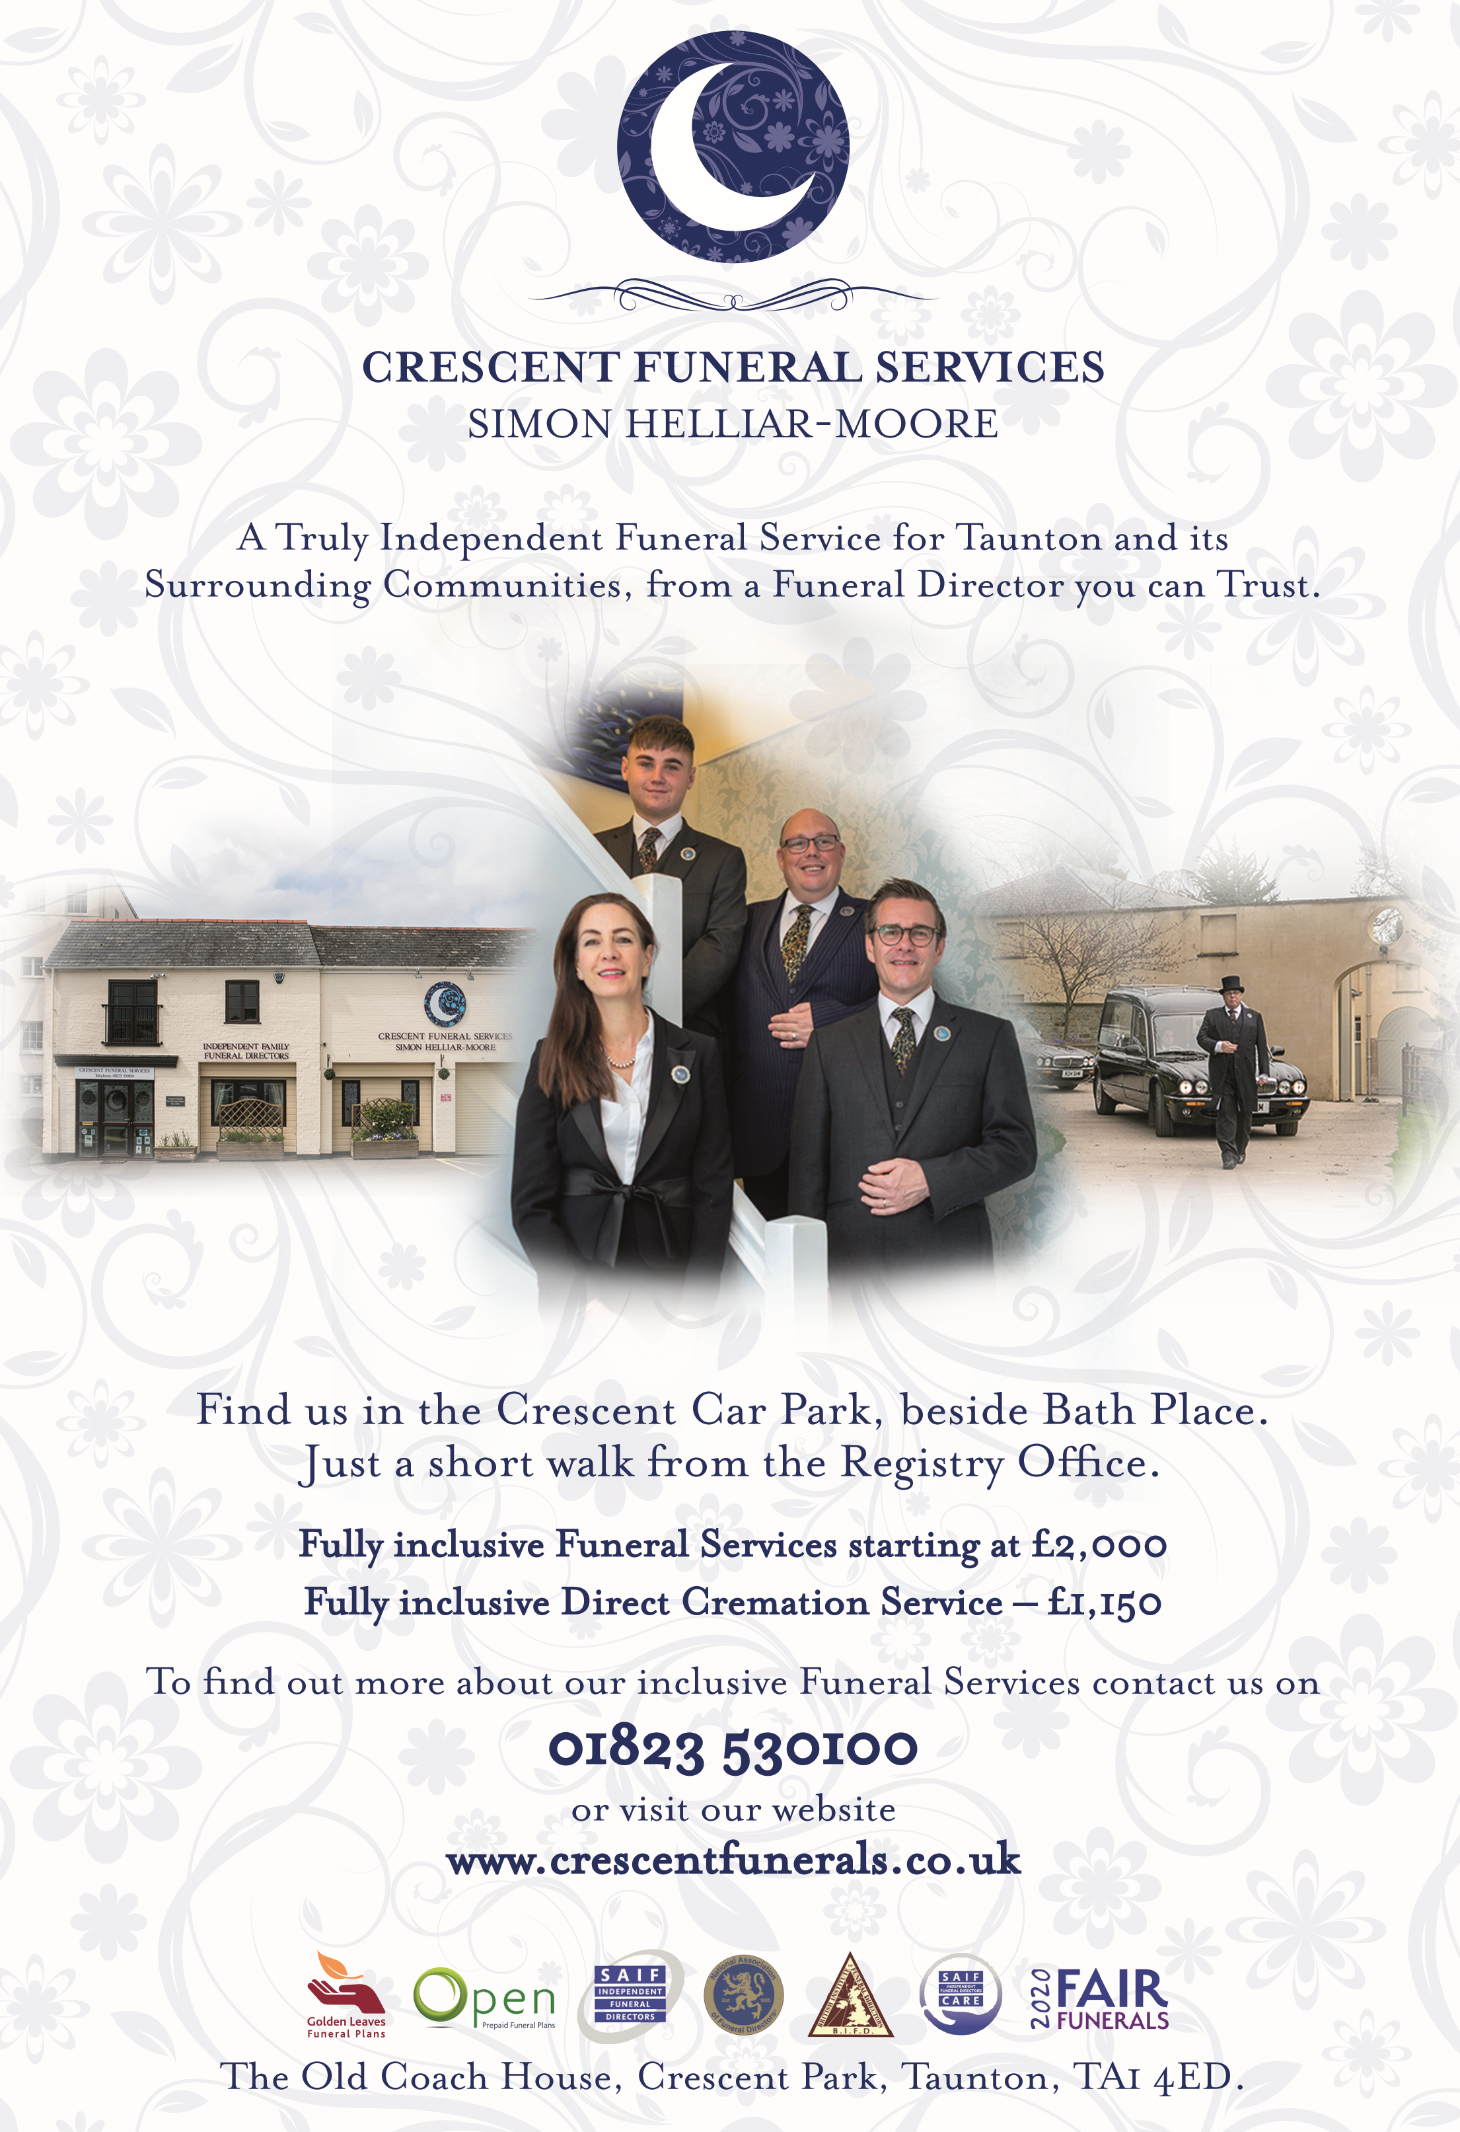
01823 777117

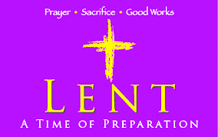
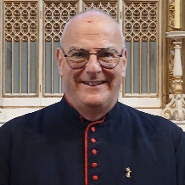
FR JULIAN WRITES…

March 2025

Lent is nearly upon us, and we are girding our loins for the rigours of our Lenten disciplines. As usual, there are many opportunities for you to take part in both liturgically and privately at home, as well as a discussion group based on the Creed, as advertised in last month’s Outlook.

In 325, 1700 years ago, a gathering of Christian bishops was called by the Roman Emperor, Constantine. Remember, that only a decade or so earlier Christians were persecuted until Constantine’s conversion around 317. As Christianity was an underground movement, its teachings were not universally known or accepted; several theories about the nature of Christ emerged.

The main arguments were whether Christ was created, or truly divine. From May till July, the Council, made up of bishops, priests and deacons from all over the Roman empire, met in Nicaea to look into this and also to settle the date of Easter. From the Council emerged what we now know as the Nicene Creed, said at Mass on Sundays and on feast days. There are two others: the Apostles’ Creed which is used at Evening Prayer, and the Athanasian, rarely used now, and formerly used on Trinity Sunday.

Athanasius was an adviser to Bishop Alexander of Alexandria (and eventually succeeded him) as he was a noted theologian. Alexander called the Council to refute the growing teachings of Arius, who taught that Jesus was a created being, used by the Father, rather than being co-equal with the Father (and Holy Spirit), having existed before all time. The creed which the Council drew up confirmed the divinity of Christ, and also that the Holy Spirit proceeded from both the Father and Son - ‘filioque’ (‘and the Son’).

Eventually, this led, in 1054, to the ‘Great Schism’, when the Orthodox Church in the East split for the Catholic Church in the West. Cultural and theological tensions have been running high for centuries, and the Pope’s excommunication of the Patriarch of Constantinople (the church of the east) was the final straw. Since then, the two churches have been completely separate, theologically differing over the ‘filioque’ clause, and also ‘homo-ousios’, referring to the creed’s statement that Jesus was of the same, not like, substance of the Father. And although the date of Easter was agreed for western churches, it was not for the east, a difference which still exists today (although this year the Orthodox Easter coincides with ours).

Events of 1700 years ago may all seem somewhat academic today, and we might think that it’s all done and dusted. However, although the Christian faith is not attacked openly today as it was before Constantine’s conversion, people are still being persecuted for their Christian faith today. It is said that in the 20th century there were more martyrs than in any other century. The main attack on Christianity is through the invidious erosion of accepted teaching of doctrine and liturgy. The Church itself colludes in this, in not standing firm, but caving in to public pressure and desire. And each of us may be challenged in various ways to defend the apostolic tradition of which we are part; unless we know and can express our faith, that faith will be diminished.

Heresies, departures from the accepted faith, may not be focussed on one person such as Arius in the 4th century, but they still very much exist. If your blood pressure is raised by the debates in the General Synod of the Church of England, it may be because you are actually on the side of the angels! But to know and to understand why something is wrong, and to be able to express it, is far more convincing than a ‘gut feeling’ or ‘Because I say so’! So, after a few years of exploring saints, from this month, I’m going to be looking at aspects of our faith and worship.

With my prayers and all good wishes

Fr Julian

WHY AND WHAT…?

In this new series, let’s start with the basics, the fundamentals of the Christian faith – the Sacraments. In the 5th Cent, St Augustine of Hippo defined a sacrament as ‘the outward and visible sign of God’s inward and invisible grace’, a definition which is still part of the Catechism of the Church. That doesn’t necessarily explain what or why. So a few thoughts, which may provoke more!

The purpose of sacraments is to display God’s presence in creation, in our lives, and to make tangible his relationship with us. St John’s great slogan is ‘God is love’. We love people in different ways, and we show that love according to our relationship: partner, families, friends, the Christian community and so on. And so does God in the sacraments, of which there are seven.

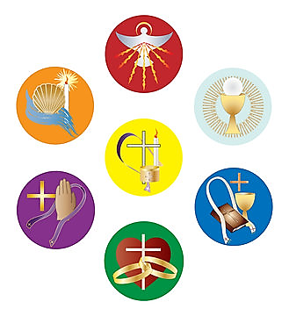
Baptism when we begin our lives as Christians, filled with the Holy Spirit and adopted as God’s children. Outward sign? Water. Inward? Union with Christ, forgiveness of sins, new life in the Spirit.

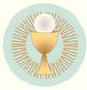
Holy Communion when we are fed by Christ’s Body and Blood, ‘re-membered’, united across the millennia with the events of the Last Supper, and reminded of our salvation. Outward sign? Bread and wine. Inward? Receiving the true Body and Blood of Christ.

These are ’dominical’ sacraments, specifically commanded by the Lord (‘domine’); the others are less clearly so and derived from the bible.

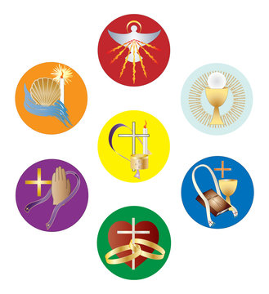
Confirmation when we profess for ourselves the promised made on our behalf at baptism. Outward sign? The laying-on of the bishop’s hands. Inward? The deepening experience of the Holy Spirit.

Marriage when ‘two become one flesh’. Outward sign? The joining of hands enveloped in the priest’s stole. Inward? The intention of God to unite fully as Christ is united with his Church.

Ordination when someone is made a member of the clergy. Outward sign? Again the laying-on of hands, and usually the anointing with holy oil. Inward? The change of being as a ‘set apart’ person – not necessarily more important! – in service to God’s people.

Confession when in accordance with the bible and the BCP, an individual is restored to God’s favour. Outward sign? The sign of the cross at absolution. Inward? The certainty of the forgiveness of personal sin, and reconciliation with God.

Anointing when Holy Oils are used on a person. Outward sign? The oil itself on the forehead and hands at the beginning of the baptism process (Oil of Catechumens); baptism, confirmation and ordination (Oil of Chrism); at times of danger (Oil of Infirmarium – the Sick). Outward sign? Oil blessed by a bishop. Inward? The knowledge of God’s loving and healing presence.

If you think about it, all these sacraments are administered at key stages of life, rites of passage, when we move on from one thing to another. This can be scary, so to know and experience outwardly and inwardly God’s love is a wonderful thing. They don’t just make us feel better and stronger in our physical lives, they draw us closer into the life and purposes of God. So even if we haven’t received them all, whether we are privileged to receive them daily or weekly, whether they are a one-off, let us thank God for them, and make use of them.
Fr Julian

MOTHERING SUNDAY

This year the 4th Sunday in Lent, Refreshment or Mothering Sunday, falls on the 30th March, which is the 5th Sunday of the month. Usually, we would join with our brothers and sisters of the Good Shepherd here or there, but we won’t do so for the Mass that day, so that we can celebrate in our own churches. However, we will still have a joint service, a treat for us both: Solemn Evensong and Benediction at 6pm.

This is also the weekend when the clocks go forward (groan!) so it will be lighter in the evenings. If you need a lift, please arrange amongst yourselves or sign the list which will be at the back of church – but do some along!

CALENDAR FOR MARCH

The Sundays, readings and themes, and Saints days for March are listed below.

1 Sat S. David, Patron Saint of Wales (401)

2 NEXT BEFORE LENT Theme: Transfiguration

Readings: Exodus 34.29-35; 2 Corinthians 3.12-4.2; Luke 9.28-36

4 Tue S. Casimir, Patron of Poland & Lithuania (1484)

5 Wed ASH WEDNESDAY Theme: True Penitence

Readings: Joel 2.1-2&12-17; 2 Cor 5.20b-6.10; Matthew 6.1-6&16-21

7 Fri SS. Perpetua, Felicity & Companions, Martyrs (203)

8 Sat Edward King, Bishop of Lincoln (1910)

9 LENT 1 Theme: God in the Wilderness

Readings: Deuteronomy 26.1-11; Romans 10.8b-13; Luke 4.1-13

11 Tue S. Sophronius, Patriarch of Jerusalem (638)

16 LENT 2 Theme: Jerusalem, Jerusalem!

Readings: Genesis 15.1-12&17-18; Philippians 3.17-4.1; Luke 13.31-35

17 Mon S. Patrick, Bishop, Missionary, Patron of Ireland (460)

18 Tue S. Cyril of Jerusalem, Archbishop (386)

19 Wed S. Joseph of Nazareth, Husband of Our Lady (1st Cent.)
20 Thu S. Cuthbert, Bishop of Lindisfarne, Missionary (687)
21 Fri Thomas Cranmer, Archbishop of Canterbury, Martyr (1556)

23 LENT 3 Theme: The Lord of Love

Readings: Isaiah 55.1-9; 1 Corinthians 10.1-13; Luke 13.1-9

24 Mon Walter Hilton, Mystic (1396)

25 Tue THE ANNUNCIATION

30 LENT 4 Theme: Mothering Sunday

Readings: Exodus 2.1-10; Colossians 3.12-17; John 19.25b-27

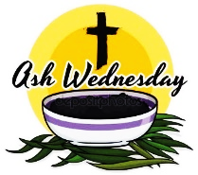
Ash Wednesday
Wednesday 5th March
7.30pm
Mass and Imposition of Ashes


EVENTS IN LENT

Holy Trinity’s programme for Lent is as follows:


Stations of the Cross:
Fridays, from 7th March, 6.00pm. A simple devotion as we follow the journey of Jesus from his trial to his burial.

Compline:
Tuesdays from 11th March, 8.00pm. The traditional version of the service will be used.

Discussion Group:
Thursdays, 7.30pm, at the Vicarage.
2025 is the 1700th anniversary of the Council of Nicea, at which the main creed, statement of faith, of the Church was agreed. To mark this anniversary, the Lent groups will be based around the ‘Nicene’ creed looking at what is a creed, and the four marks of the Church as declared in the creed.

6th March: God the Father
13th March: God the Son, the Incarnation
20th March: Redemption
27th March: The Holy Spirit
3rd April: Holy Catholic and Apostolic
10th April: The Last Things

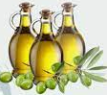
Chrism Mass
10th April, Exeter Cathedral
11am Mass, followed by a buffet lunch
2.15pm Catechesis, 3pm Benediction


Seder Meal
Saturday 12th April, 7pm. A traditional Passover meal such as Jesus might have shared with his disciples at the Last Supper

SHROVE TUESDAY PARTY

Tuesday 4th March, 7pm, in the church hall
There will be a Fish & Chip Supper followed by Pancakes, Tickets £10


Spotlight on…

Sylvie Paul
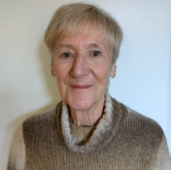

I have been speaking this month with our fabulous ‘flower lady’ Sylvie Paul. She tells me she has been doing this for twenty years and forages for the greenery to adorn our church.

Thank you so very much for speaking with me today Sylvie, whereabouts were you born, do you have any family and what did you do for a living?
I was born in Taunton and lived just a stones-throw from Holy Trinity, in Noble Street. I went to school at Trinity School which was adjacent to the Church, followed by Asquith (which was situated where Trinity School now stands. It was here that I met Pat (Deal) who became my best friend. I was a member of the Sunday School at Trinity and later St Michaels Guild, an organisation for those who had moved on from Sunday School. There we had outings and the one that stands out for me was a trip to the Trinity Geriatric Hospital. We were supposed to visit the elderly residents but for some reason it traumatised me and I refused to go again!

When I left school I obtained a position with Marks and Spencer. On one occasion at my first Christmas, I was reprimanded for a prank when I set all the alarm clocks on a counter display to 5.30, but I was only 15 at the time! I trained as a window dresser (the arts and crafts were present then!) and my efforts were recognised and made a supervisor on the shop floor when I wasn’t dressing the windows and being occasionally seconded to other stores in the South West.

I married Michael in 1968, a Surrey boy who had come to Taunton with his family. My father was in the Somerset Light Infantry and ran the veterans social club at the Mount Street Barracks, where I helped out behind the bar. I first met Michael when he began to bring his grandfather to the social evenings. I was a member of an ’18 Plus’ group and my parents encouraged Michael to join and the rest, as they say, is history!

We had two children almost in tandem with Pat and they all went to the St Georges Playgroup and to Holy Trinity Sunday School where at one time Pat and I were both teachers until Covid struck. I had previously been asked to become a parent helper at the playgroup. When the Church were unable to form a committee I was invited to stay and run the group, provided I gave preference to catholic children. The name was changed to the Mount Pre-school and I became owner/manager until I retired twenty-six years later.

When my children were teenagers, the leader of the Trinity Youth Club left, so Michael and I stepped up (along with David Lovelock). This is probably one of the happiest times in my life. We did all the things like camping at Horner and ice skating in Bristol that I had never done as a teenager, so this was my second chance. We had some super and companionable meetings (in the pub of course) after the youngsters had gone home. A few years went by and the club folded by mutual agreement due to family and personal circumstances. We had a surplus in the funds so this was put to new vestments at Holy Trinity, it was the right thing to do. I have loved working with children and young people, I think this was my calling.

What do you do in your spare time, what are your hobbies?
Craft and artistic pursuits have always been an interest. These days I love Trinity Church Craft Group on a Thursday afternoon. There we can meet in companionship and gain strength from others when we need it. I love it. Dogs have been a recurrent theme in my life! I was never allowed to have one as a child but once married I wanted a Basset Hound but the cost was prohibitive. However, we ended up owning five dogs over the years. For the last twelve months we have adopted our daughter’s two dogs in addition to occasionally caring for friends’ dogs when there was a need. No more dogs!

What would you say is important to you and what does your faith and Holy Trinity mean to you?
My father was a Sidesman at St Marys (the Minster) and I have happily followed the tradition at Holy Trinity. When I agreed to a ‘trial’ to do flowers in the Church, it really was trial and error in the beginning but I have had so much encouragement and learnt so much, particularly from Lisa (a trained florist). I love doing it.
My faith and Holy Trinity are all to me. I have spent my life here, have grown up with fellow parishioners and it is where I feel safe. ‘It’s me’.

Thank you Sylvie, it’s so interesting to learn about the lives of people we might not know so well, I had no idea you had so much of an impact on the lives of young people.
Pauline Holt

A RECIPE FOR MARCH

FASTING BREAD FOR LENT - and its symbolism

This bread combines pure, wholesome ingredients with symbolic references found in Sacred Scripture. Makes 3 loaves.

Ingredients

3½ cups Stone Ground Whole Wheat Flour
2½ cups All Purpose Flour
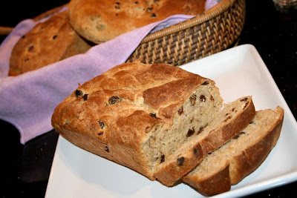
1½ tsp Salt
1 tbs Sugar
4½ tsp Active Dry Yeast
2 cups Luke Warm Water
½ cup 100% Pure Maple Syrup
½ cup Olive Oil
1 tsp Water (Holy water if possible)
1 cup Oats – soaked in ½ cup hot water for 2 minutes
1 cup Pecan or Walnut pieces – broken and skillet toasted 2 min
1 cup Dried Cherries or Raisins - soaked 5 min in ¼ cup hot water

Method

- Combine the first three dry ingredients in a large mixing bowl. Mix well with a whisk.
- Clear a small area in the centre of the dry blend. Add sugar, dry yeast, and the 2 cups of warm water. Let stand for 3 minutes until yeast proves and forms bubbles. Combine flour mixture and liquid. This will be thick but more liquid comes later.
- Add maple syrup, olive oil and (holy) water. Stir mixture until well blended. Then add walnuts and/or pecans and raisins and/or cherries with their liquid and add soaked oats to the flour mixture. Blend everything together in one bowl.
- Turn out onto a floured board and knead by hand for 10-12 minutes adding more flour as needed to make a moderately stiff dough that is smooth and elastic. Knead until the dough is smooth and elastic and forms a ‘ball’.
- Return the ‘ball’ to the mixing bowl, drizzle with olive oil, cover and let rise for an 1 hour. Remove to a floured board and knead several more times as above.
- Cut into three equal pieces. Place each piece into a loaf pan coated on all sides with olive oil. Drizzle loaf again with olive oil, cover and let rise for another hour.
- Slash loaf tops and bake in the middle of a preheated 375º oven for 40 minutes or until brown on top and bottom. Loaf should sound hollow when tapped.
- Remove bread from pans and cool on a rack.

Some Symbolic References

Stone Ground Wheat and Oats – ‘Unless a grain of wheat falls to the ground and dies, it remains alone. But if it dies, it brings forth much fruit.’
Yeast– Unifying many parts into one; a symbol of the kingdom of heaven and of the Church.
Salt – Christ said to his Apostles: ‘You are the salt of the earth.’
Water – Giving life to all things; a symbol of baptism; cleansing. Lenten penances aid the washing away our sins.
Olive Oil – Olive oil is used by the Church in the Holy Oils applied in sacramental anointing.
Walnuts and Pecans and Cherries – These fruits of the earth are reminders of Christ’s command to go forth and produce good fruit and of the fruit of good works to be undertaken during Lent through works of charity, prayer, fasting and almsgiving.
Raisins – Made from grapes, raisins are the fruit of the vine; a reminder of the wine changed into the Blood of Christ at the Last Supper and at the Consecration during Mass.

Contributed by Jane Laurence

COFFEE MORNING & HOUSE WARMING

Lady Day - Tuesday, 25th March, 10.45am
at 32 Holway Road, home of Fr James Finnemore


Cakes etc.
Donations for Holy Trinity
All welcome
(Some parking permits available, limited parking at rear of the house)

NB: Lady Day Mass at 10am.
All rose bushes should have been pruned before this day!

DATES FOR YOUR DIARY

Saturday 14 June Summer Fair
Saturday 16 August Barbecue
Saturday 6 September Glastonbury Pilgrimage
Saturday 4 October Harvest Supper
Saturday 6 December Christmas Fair


BEWARE OF THESE CONTAGIOUS DISEASES IN CHURCH

Frontophobia: A morbid fear of the front seats in church. The sufferer is struck by an attack just inside the church door, and so collapses in the nearest back seat.
Sermonic Throat: A dreaded choking caused by the start of the sermon. The sufferer unwraps a sweet very slowly and noisily, which seems to effect a complete cure.
Double Auricular Clearance: A condition due to the simultaneous opening of both ear ducts, which allows sound to enter one ear and leave the other without any absorption thereof. Condition is acute during Bible readings and sermon.
Accelerated or Retarded Vocal Response: Conditions which cause the sufferer to try to sing faster or slower than the organ.
Theexits: A condition where the sufferer rushes for the exit before the minister gets there.
Church Meeting Paralysis: This can strike suddenly, when a post in the church needs filling. A good dose of enthusiasm works wonders with this sad affliction.
From the Parish Pump
A BACKWARD SPRING by Thomas Hardy (1840 - 1928)

Thomas Hardy is perhaps better known for his novels rather than his poetry, which I think is a pity. Here he captures the uncertainty of March weather, Winter is not over, Spring has yet to arrive, looking back at Winter and forward to Spring and its written from the viewpoint of the plants themselves.

He paints a word picture based on observation, just as an artist paints a real picture. Notice how he carries the rhyme of the last two lines of the first verse forward into the second verse.

I think this is a cracking poem.

The trees are afraid to put forth buds,
And there is timidity in the grass;
The plots lie gray where gouged by spuds,
And whether next week will pass
Free of sly sour winds is the fret of each bush

Of barbary waiting to bloom.

Yet the snowdrop’s face betrays no gloom,
And the primrose pants in its heedless push,

Though the myrtle asks if it’s worth the fight
This year with frost and rime
To venture one more time
On delicate leaves and blossoms of white
From the selfsame bough as at last year’s prime,
And never to ruminate on or remember
What happened to it in mid-December.

Pat Hitchcock

EASTER LILIES

There will be an opportunity as usual to remember loved ones through Easter lilies this year. Forms will be available shortly. Please return forms by Mothering Sunday, 30th March.

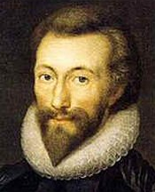
JOHN DONNE - The metaphysical poet

In last month’s Outlook I wrote about George Herbert who was one of the so called ‘metaphysical’ poets. This month sees the feast day on 31st March of another, and probably the greatest, metaphysical poet John Donne (1572 – 1631).

Metaphysical poets were a group of 17th-century English poets who wrote in a style that was witty, intellectual, and challenging. Their work often explored themes of love, religion, and morality.

John Donne was a poet, scholar, soldier, secretary and priest. Donne was born in 1572 into a Roman Catholic family in London at a time when practice of Catholicism was illegal in England. Although Donne studied at both Oxford and Cambridge, because of his Catholicism, he was denied a degree. So, in 1592 Donne went to London to study law at Lincoln’s Inn. The death of Donne’s brother in prison for harbouring a Catholic priest, led him to question his faith and in 1594 he converted to the Church of England, and this opened up a whole new life for him.

During and after his education, Donne spent much of his considerable inheritance on women, literature, pastimes and travel. He became a soldier and fought against the Spanish. When he returned in 1598, he was appointed private secretary to Sir Thomas Egerton, Lord Keeper of the Seal. All was going well until in 1601 he secretly married Egerton’s 16-year-old niece, Anne More. Egerton was furious, and Donne lost his job, and even ended up in prison for a short time.

Despite his great education and poetic talents, Donne lived in poverty for several years, relying heavily on wealthy friends and patrons, for whom many of his poems were written, or sometimes working as a lawyer. He also sat as a Member of Parliament, firstly for Brackley in 1601, then as MP for Taunton in 1614.

He caught the eye of King James 1, who seems to have told Donne to take holy orders. Although he did not want to he obeyed the king’s wishes and in 1615 was ordained deacon, then priest in the Church of England, and was appointed as a royal chaplain.

In 1617 Donne’s beloved wife, Anne, died, five days after giving birth to their twelfth child. Throughout his working life, Donne continued to write poetry, both sacred and secular poetry, with his main theme being that of human love and divine love. Donne had a number of clerical appointments until in 1621 he was appointed Dean of St Paul’s Cathedral where he stayed until his death. Donne died on 31 March 1631. He was buried in old St Paul's Cathedral, where a memorial statue of him was erected with a Latin epigraph probably composed by himself. The memorial was one of the few to survive the Great Fire of London in 1666 and is now in today’s St Paul's Cathedral.

Jane Laurence


THE SUNDAY LUNCH CLUB
will be visiting the following:

9 March The Hankridge Arms
13 April The Anchor, Hillfarrance (£10 deposit)
11 May Pickeridge Golf Club
8 June The Maypole, Thurloxton (£5 deposit)

All bookings are for 12.15. Please let me know if you want to come along to any of the lunch club outings on the previous Sunday so that numbers can be confirmed with the venue.

If you need a lift please make sure you arrange transport beforehand with one of the drivers.
Wendy Burge



HOLY TRINITY WINNERS

January 2025
1st Aart Dourleyn £55.00
2nd Jenni Llewellyn £33.00
3rd Julie Harland £22.00

ALL IN THE MONTH OF MARCH

It was:

- 175 years ago, on 5th March 1850 that the Britannia Bridge linking Anglesey and mainland Wales across the Menai Strait was officially opened. Designed and built by railway engineer Robert Stephenson, it had to be replaced after a disastrous fire in 1970.
- 150 years ago, on 7th March 1875 that the French composer Maurice Ravel was born. Best known for Bolero.
- 125 years ago, on 28th March 1900 that the British archaeologist Arthur Evans began excavating the ancient city of Knossos, capital of the Minoan civilisation, in Heraklion, Crete. It is regarded as the oldest city in Europe but was abandoned more than 3,000 years ago.
- 90 years ago, on 16th March 1935 that driving tests were first introduced in Britain. Three days later, on 19th March, a speed limit of 30 mph in built-up areas was also introduced.
- 70 years ago, on 11th March 1955 that Sir Alexander Fleming, Scottish bacteriologist died. Joint winner of the 1945 Nobel Prize in Physiology or Medicine for discovering penicillin
- 60 years ago, on 18th March 1965 that Soviet cosmonaut Aleksei Leonov became the first person ever to make a spacewalk.
- 50 years ago, on 26th March 1975 that the Biological Weapons Convention came into effect. This multilateral disarmament treaty banned the development, production and stockpiling of all biological and toxin weapons.
- 40 years ago, on 3rd March 1985, British miners voted to return to work after a year-long strike over pit closures and job losses.
- 30 years ago, on 2nd March 1995 that the ‘rogue trader’ Nick Leeson was arrested for his role in the collapse of Barings, Britain’s oldest merchant bank.
- 20 years ago, on 10th March 2005, Dave Allen, Irish comedian, died.
- 10 years ago, on 12th March 2015 that Terry Pratchett, British fantasy novelist, died of Alzheimer’s, aged 66.

From the Parish Pump

MAGAZINE DEADLINE: Wednesday 19th March 2025


SAFEGUARDING

At Holy Trinity we take safeguarding
very seriously and are committed to
the safety of all our members.

If you have any safeguarding concerns,
please contact the Parish Safeguarding Officer by email htsafeguarding@outlook.com, or
through a dedicated Safeguarding Line 07596 223932

All contacts are confidential unless you give us permission to share it, or unless someone is at immediate risk.



PARISH DIRECTORY

VICAR Fr Julian Laurence 01823 337890

HON. ASST. CLERGY Bishop Michael Langrish
Fr James Finnemore

LAY PASTORAL Mrs Jane Laurence 01823 354800
ASSISTANTS Mrs Jenni Llewellyn (Church Office)

CHURCHWARDENS Mr John Godley 01823 354800
Mrs Jenni Llewellyn (Church Office)
DEPUTY CHURCHWARDEN Mrs Liz Hathway

SAFEGUARDING OFFICER Mrs Jo Bailey / Mrs Charis Cavaghan-Pack
DEDICATED SAFEGUARDING LINE 07596 223932

PARISH OFFICE Administrator: Mrs Pauline Holt 354800

PCC Vice-Chairman Mr Geraint Jones 01823 284376

PCC Treasurer Mrs Pauline Holt (Church Office) 354800

PCC Secretary Mr Keith Penny (Church Office) 354800

Electoral Roll Secretary Mr Richard Tomlinson (Church Office) 354800

Data Protection Mr Keith Penny (Church Office) 354800

Organist & Choir Trainer Mr Simon Gaunt 01984 641584

Editor of 'Outlook' Mrs Jane Laurence 01823 337890

'Outlook' advertising Parish Administrator 01823 354800

Sacristan Mrs Jenni Llewellyn 01823 354800

Captain of Bellringers Mrs Margaret Jordan 07972 524557

Church Flowers Mrs Sylvie Paul 01823 279436

Hall Booking Secretary Parish Administrator 01823 354800

Trinity Church School Trinity School, South Street 01823 284128
Head of School Ms Lisa Eadie

Website: www.holytrinitytaunton.org
Email: holytrinity01@outlook.com Facebook: Holy Trinity Taunton

